· 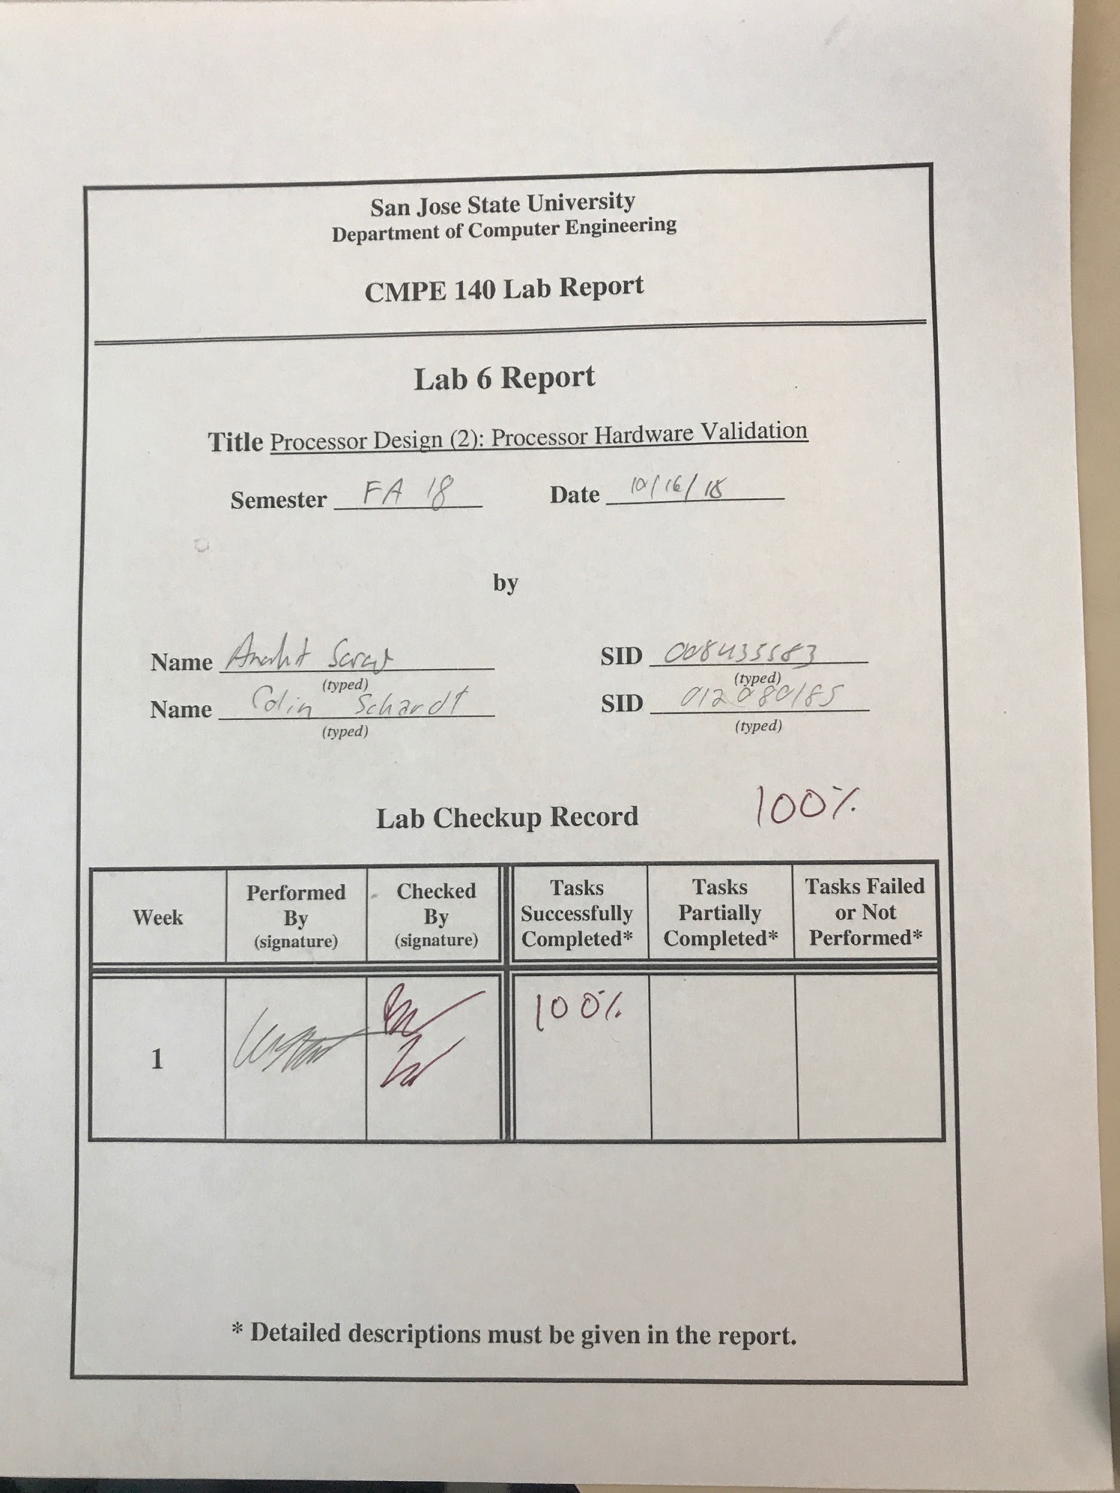

***Design Methodology***

This is lab is an extension of lab 5, the lab requires full hardware validation testing for the single-process cpu. Additional files were added to the project such as the xdc constraints file and multiple design files. Provided below is a block diagram showing the testing environment. The learning outcome for this lab was to validate the MIPS processor design using the FPGA board. This allows the cpu to undergo software and hardware validation.

Tasks which were completed in lab:

- Diagram showing validation environment setup.

- Verify the hardware functionality using the FPGA.

- Compare the FPGA validation results with test log from Lab 2.

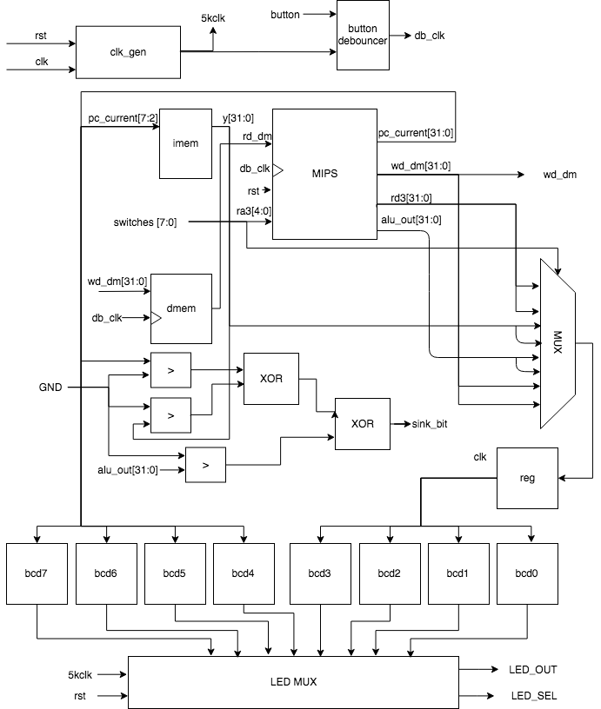

Figure 1. Validation Environment Setup

| Adr | Expected Machine Code | Actual Machine Code | PC | Registers | | | | | Memory Content | |
| --- | --- | --- | --- | --- | --- | --- | --- | --- | --- | --- |
| $v0 | $v1 | $a0 | $a1 | $a3 | [80] | [84] |
| 00 | 20020005 | 20020005 | 0 | 5 |  |  |  |  |  |  |
| 04 | 2003000c | 2003000c | 4 | 5 | 12 |  |  |  |  |  |
| 08 | 2067fff7 | 2067fff7 | 8 | 5 | 12 |  |  | 3 |  |  |
| 0c | 00e22025 | 00e22025 | C | 5 | 12 | 7 |  | 3 |  |  |
| 10 | 00642824 | 00642824 | 10 | 5 | 12 | 7 | 4 | 3 |  |  |
| 14 | 00a42820 | 00a42820 | 14 | 5 | 12 | 7 | 11 | 3 |  |  |
| 18 | 10a7000a | 10a7000a | 18 | 5 | 12 | 7 | 11 | 3 |  |  |
| 1c | 0064202a | 0064202a | 1c | 5 | 12 | 0 | 11 | 3 |  |  |
| 20 | 10800001 | 10800001 | 20 | 5 | 12 | 0 | 11 | 3 |  |  |
| 24 | 20050000 | Not taken |  |  |  |  |  |  |  |  |
| 28 | 00e2202a | 00e2202a | 28 | 5 | 12 | 1 | 11 | 3 |  |  |
| 2c | 00853820 | 00853820 | 2c | 5 | 12 | 1 | 11 | 12 |  |  |
| 30 | 00e23822 | 00e23822 | 30 | 5 | 12 | 1 | 11 | 7 |  |  |
| 34 | ac670044 | ac670044 | 34 | 5 | 12 | 1 | 11 | 7 | 7 |  |
| 38 | 8c020050 | 8c020050 | 38 | 7 | 12 | 1 | 11 | 7 | 7 |  |
| 3c | 08000011 | 08000c11 | 3c | 7 | 12 | 1 | 11 | 7 | 7 |  |
| 40 | 20020001 | Not taken |  |  |  |  |  |  |  |  |
| 44 | ac020054 | ac020054 | 44 | 7 | 12 | 1 | 11 | 7 | 7 | 7 |
| 48 | 08000000 | 08000c00 | 48 | 7 | 12 | 1 | 11 | 7 | 7 | 7 |

Table 1. Test Results Log

***FPGA Test Plan***

For hardware validation the register values, machine code, and memory content were analyzed.

Using the FPGA to output all these values in every clock cycle. The values were compared to the output obtained in lab 2. Similar to the MIPS assembler the values did not change in memory till the next clock cycle.

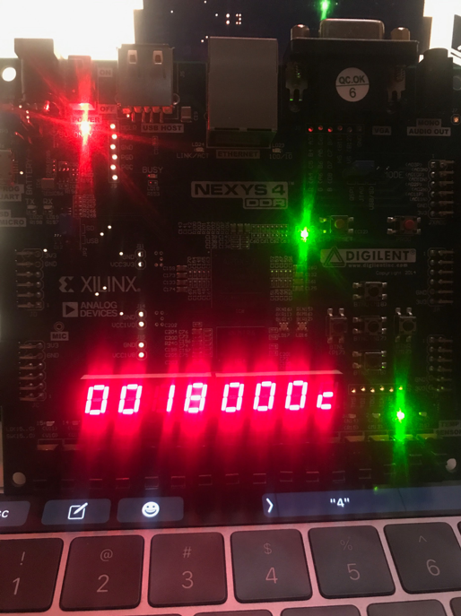

Figure 2. 7-Segment Display Showing Machine Code & Address

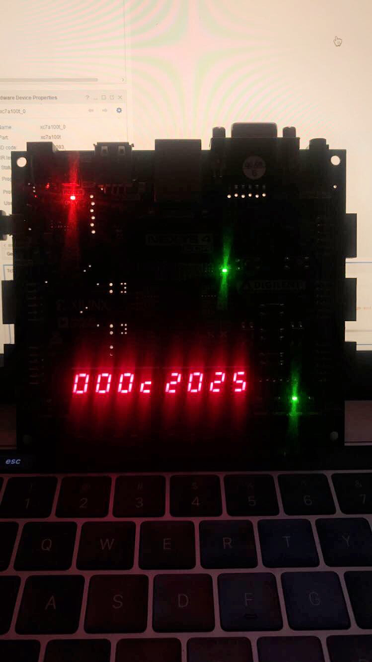

Figure 3. 7-Segment Display Showing Contents of Registers & Address

***Conclusion***

In conclusion the was easily finished as it was straightforward and easy to execute. The main functionality of this lab was to connect the data path and control unit then using a set of control signals to input instructions that would alter the output and control values. The control unit and data path along with the machine code and hardware unit helps understand the change in every instruction set as they are not all the same.

***Source Code***

| mips_fpga.v |
| --- |
| module mips_fpga (  input wire clk,  input wire rst,  input wire button,  input wire [7:0] switches,  output wire we_dm,  output wire [7:0] LEDSEL,  output wire [7:0] LEDOUT  );  reg [15:0] reg_hex;  wire clk_sec;  wire clk_5KHz;  wire clk_pb;    wire [7:0] digit0;  wire [7:0] digit1;  wire [7:0] digit2;  wire [7:0] digit3;  wire [7:0] digit4;  wire [7:0] digit5;  wire [7:0] digit6;  wire [7:0] digit7;  wire [31:0] pc_current;  wire [31:0] instr;  wire [31:0] alu_out;  wire [31:0] wd_dm;  wire [31:0] rd_dm;  wire [31:0] dispData;  clk_gen clk_gen (  .clk100MHz (clk),  .rst (rst),  .clk_4sec (clk_sec),  .clk_5KHz (clk_5KHz)  );  button_debouncer bd (  .clk (clk_5KHz),  .button (button),  .debounced_button (clk_pb)  );  mips_top mips_top (  .clk (clk_pb),  .rst (rst),  .ra3 (switches[4:0]),  .we_dm (we_dm),  .pc_current (pc_current),  .instr (instr),  .alu_out (alu_out),  .wd_dm (wd_dm),  .rd_dm (rd_dm),  .rd3 (dispData)  );  /*  switches[4:0] are used as the 3rd read address (ra3) of the RF,  dispData is the register contents from the RF's 3rd read port (rd3).  */  hex_to_7seg hex7 (  .HEX (pc_current[15:12]),  .s (digit7)  );  hex_to_7seg hex6 (  .HEX (pc_current[11:8]),  .s (digit6)  );  hex_to_7seg hex5 (  .HEX (pc_current[7:4]),  .s (digit5)  );  hex_to_7seg hex4 (  .HEX (pc_current[3:0]),  .s (digit4)  );  hex_to_7seg hex3 (  .HEX (reg_hex[15:12]),  .s (digit3)  );  hex_to_7seg hex2 (  .HEX (reg_hex[11:8]),  .s (digit2)  );  hex_to_7seg hex1 (  .HEX (reg_hex[7:4]),  .s (digit1)  );  hex_to_7seg hex0 (  .HEX (reg_hex[3:0]),  .s (digit0)  );  led_mux led_mux (  .clk (clk_5KHz),  .rst (rst),  .LED7 (digit7),  .LED6 (digit6),  .LED5 (digit5),  .LED4 (digit4),  .LED3 (digit3),  .LED2 (digit2),  .LED1 (digit1),  .LED0 (digit0),  .LEDSEL (LEDSEL),  .LEDOUT (LEDOUT)  );    /*  switches[7:5] = 000 : Display lower half word of register selected by switches[4:0]  switches[7:5] = 001 : Display higher half word of register selected by switches[4:0]  switches[7:5] = 010 : Display lower half word of 'instr'  switches[7:5] = 011 : Display higher half word of 'instr'  switches[7:5] = 100 : Display lower half word of 'alu_out'  switches[7:5] = 101 : Display higher half word of 'alu_out'  switches[7:5] = 110 : Display lower half word of 'wd_dm'  switches[7:5] = 111 : Display higher half word of 'wd_dm'  */  always @ (posedge clk) begin  case ({switches[7:5]})  3'b000: reg_hex = dispData[15:0];  3'b001: reg_hex = dispData[31:16];  3'b010: reg_hex = instr[15:0];  3'b011: reg_hex = instr[31:16];  3'b100: reg_hex = alu_out[15:0];  3'b101: reg_hex = alu_out[31:16];  3'b110: reg_hex = wd_dm[15:0];  3'b111: reg_hex = wd_dm[31:16];  endcase  end  endmodule |

| lab6.asm |
| --- |
| main:  addi $2, $0, 5  addi $3, $0, 12  addi $7, $3, -9  or $4, $7, $2  and $5, $3, $4  add $5, $5, $4  beq $5, $7, end  slt $4, $3, $4  beq $4, $0, around  addi $5, $0, 0  around:  slt $4, $7, $2  add $7, $4, $5  sub $7, $7, $2  sw $7, 68($3)  lw $2, 80($0)  j end  addi $2, $0, 1  end:  sw $2, 84($0)  j main |

| mips_fpga.xdc |
| --- |
| # Clock Signal  set_property -dict {PACKAGE_PIN E3 IOSTANDARD LVCMOS33} [get_ports {clk}];  create_clock -add -name sys_clk_pin -period 10.00 -waveform {0 5} [get_ports {clk}];  # Buttons  set_property -dict {PACKAGE_PIN N17 IOSTANDARD LVCMOS33} [get_ports {button}]; # Center Button  set_property -dict {PACKAGE_PIN P17 IOSTANDARD LVCMOS33} [get_ports {rst}]; # Left Button  # Switches  set_property -dict {PACKAGE_PIN J15 IOSTANDARD LVCMOS33} [get_ports {switches[0]}]; # Switch 0  set_property -dict {PACKAGE_PIN L16 IOSTANDARD LVCMOS33} [get_ports {switches[1]}]; # Switch 1  set_property -dict {PACKAGE_PIN M13 IOSTANDARD LVCMOS33} [get_ports {switches[2]}]; # Switch 2  set_property -dict {PACKAGE_PIN R15 IOSTANDARD LVCMOS33} [get_ports {switches[3]}]; # Switch 3  set_property -dict {PACKAGE_PIN R17 IOSTANDARD LVCMOS33} [get_ports {switches[4]}]; # Switch 4  set_property -dict {PACKAGE_PIN T18 IOSTANDARD LVCMOS33} [get_ports {switches[5]}]; # Switch 5  set_property -dict {PACKAGE_PIN U18 IOSTANDARD LVCMOS33} [get_ports {switches[6]}]; # Switch 6  set_property -dict {PACKAGE_PIN R13 IOSTANDARD LVCMOS33} [get_ports {switches[7]}]; # Switch 7  # LEDs  set_property -dict {PACKAGE_PIN H17 IOSTANDARD LVCMOS33} [get_ports {we_dm}]; # LED 0  # 7 Segment Display  set_property -dict {PACKAGE_PIN T10 IOSTANDARD LVCMOS33} [get_ports {LEDOUT[0]}]; # CA  set_property -dict {PACKAGE_PIN R10 IOSTANDARD LVCMOS33} [get_ports {LEDOUT[1]}]; # CB  set_property -dict {PACKAGE_PIN K16 IOSTANDARD LVCMOS33} [get_ports {LEDOUT[2]}]; # CC  set_property -dict {PACKAGE_PIN K13 IOSTANDARD LVCMOS33} [get_ports {LEDOUT[3]}]; # CD  set_property -dict {PACKAGE_PIN P15 IOSTANDARD LVCMOS33} [get_ports {LEDOUT[4]}]; # CE  set_property -dict {PACKAGE_PIN T11 IOSTANDARD LVCMOS33} [get_ports {LEDOUT[5]}]; # CF  set_property -dict {PACKAGE_PIN L18 IOSTANDARD LVCMOS33} [get_ports {LEDOUT[6]}]; # CG  set_property -dict {PACKAGE_PIN H15 IOSTANDARD LVCMOS33} [get_ports {LEDOUT[7]}]; # DP  set_property -dict {PACKAGE_PIN J17 IOSTANDARD LVCMOS33} [get_ports {LEDSEL[0]}]; # AN0  set_property -dict {PACKAGE_PIN J18 IOSTANDARD LVCMOS33} [get_ports {LEDSEL[1]}]; # AN1  set_property -dict {PACKAGE_PIN T9 IOSTANDARD LVCMOS33} [get_ports {LEDSEL[2]}]; # AN2  set_property -dict {PACKAGE_PIN J14 IOSTANDARD LVCMOS33} [get_ports {LEDSEL[3]}]; # AN3  set_property -dict {PACKAGE_PIN P14 IOSTANDARD LVCMOS33} [get_ports {LEDSEL[4]}]; # AN4  set_property -dict {PACKAGE_PIN T14 IOSTANDARD LVCMOS33} [get_ports {LEDSEL[5]}]; # AN5  set_property -dict {PACKAGE_PIN K2 IOSTANDARD LVCMOS33} [get_ports {LEDSEL[6]}]; # AN6  set_property -dict {PACKAGE_PIN U13 IOSTANDARD LVCMOS33} [get_ports {LEDSEL[7]}]; # AN7 |

| hex_to_7seg.v |
| --- |
| module hex_to_7seg (  input wire [3:0] HEX,  output reg [7:0] s  );  always @ (HEX) begin  case (HEX)  4'h0: s = 8'b11000000;  4'h1: s = 8'b11111001;  4'h2: s = 8'b10100100;  4'h3: s = 8'b10110000;  4'h4: s = 8'b10011001;  4'h5: s = 8'b10010010;  4'h6: s = 8'b10000010;  4'h7: s = 8'b11111000;  4'h8: s = 8'b10000000;  4'h9: s = 8'b10010000;  4'hA: s = 8'b10001000;  4'hB: s = 8'b10000000;  4'hC: s = 8'b11000110;  4'hD: s = 8'b11000000;  4'hE: s = 8'b10000110;  4'hF: s = 8'b10001110;  default: s = 8'b01111111;  endcase  end  endmodule |

| led_mux.v |
| --- |
| module led_mux (  input wire clk,  input wire rst,  input wire [7:0] LED7,  input wire [7:0] LED6,  input wire [7:0] LED5,  input wire [7:0] LED4,  input wire [7:0] LED3,  input wire [7:0] LED2,  input wire [7:0] LED1,  input wire [7:0] LED0,  output wire [7:0] LEDSEL,  output wire [7:0] LEDOUT  );  reg [2:0] index;  reg [15:0] led_ctrl;  assign {LEDSEL, LEDOUT} = led_ctrl;    always @ (posedge clk) index <= (rst) ? 3'b0 : (index + 3'd1);    always @ (index, LED0, LED1, LED2, LED3, LED4, LED5, LED6, LED7) begin  case (index)  3'd0: led_ctrl <= {8'b11111110, LED0};  3'd1: led_ctrl <= {8'b11111101, LED1};  3'd2: led_ctrl <= {8'b11111011, LED2};  3'd3: led_ctrl <= {8'b11110111, LED3};  3'd4: led_ctrl <= {8'b11101111, LED4};  3'd5: led_ctrl <= {8'b11011111, LED5};  3'd6: led_ctrl <= {8'b10111111, LED6};  3'd7: led_ctrl <= {8'b01111111, LED7};  default: led_ctrl <= {8'b11111111, 8'hFF};  endcase  end    endmodule |

| clk_gen.v |
| --- |
| module clk_gen (  input wire clk100MHz,  input wire rst,  output reg clk_4sec,  output reg clk_5KHz  );  integer count1, count2;  always @ (posedge clk100MHz) begin  if (rst) begin  count1 = 0;  count2 = 0;  clk_5KHz = 0;  clk_4sec = 0;  end  else begin  if (count1 == 200000000) begin  clk_4sec = ~clk_4sec;  count1 = 0;  end  if (count2 == 10000) begin  clk_5KHz = ~clk_5KHz;  count2 = 0;  end  count1 = count1 + 1;  count2 = count2 + 1;  end  end  endmodule |

| button_debouncer.v |
| --- |
| module button_debouncer #(parameter depth = 16) (  input wire clk, /* 5 KHz clock */  input wire button, /* Input button from constraints */  output reg debounced_button  );  localparam history_max = (2**depth)-1;  /* History of sampled input button */  reg [depth-1:0] history;  always @ (posedge clk) begin  /* Move history back one sample and insert new sample */  history <= { button, history[depth-1:1] };  /* Assert debounced button if it has been in a consistent state throughout history */  debounced_button <= (history == history_max) ? 1'b1 : 1'b0;  end  endmodule |